**PROJECT DEVELOPMENT PHASE**

**SPRINT 1**

**CREATION & CONFIGURATION OF IBM CLOUD SERVICES**

PROJECT TITLE- HAZARDOUS AREA MONITORING FOR INDUSTRIAL PLANT POWERED BY IOT

|  |  |
| --- | --- |
| Team ID | PNT2022TMID35923 |

Creating IBM Watson IoT Platform and Device

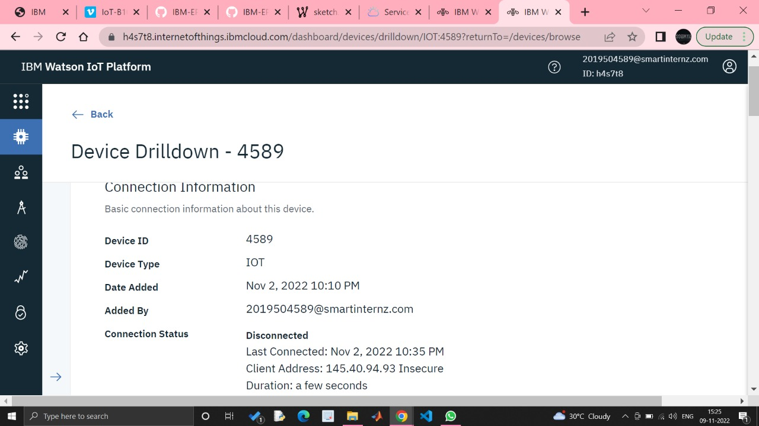

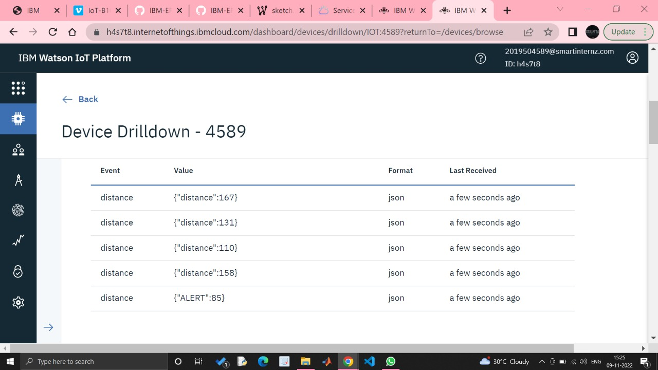

### Creating Node-RED Service

### 

### 

### 

### Creating a Database in Cloudant DB

### 

### 

### 